Cyber Forensics

Registry Editor

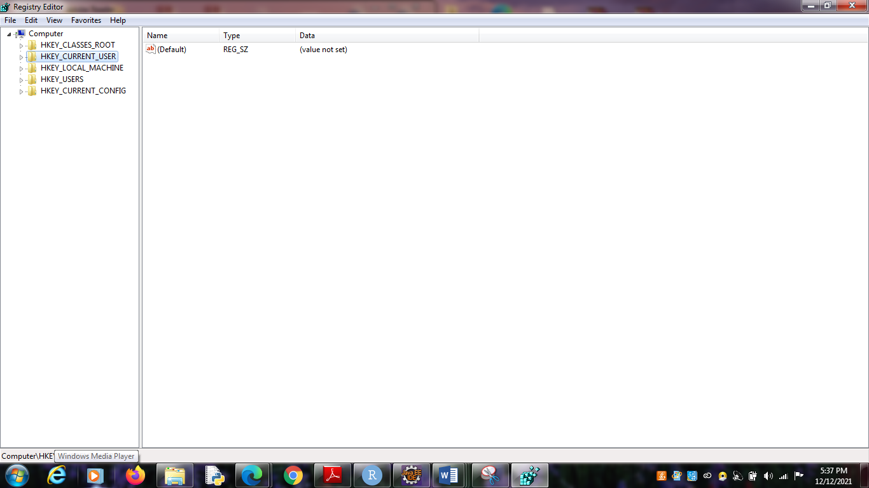

Wireless Evidence in the Registry

HKEY_LOCAL_MACHINE\SOFTWARE\Microsoft\WindowsNT\CurrentVersion\NetworkList\Profiles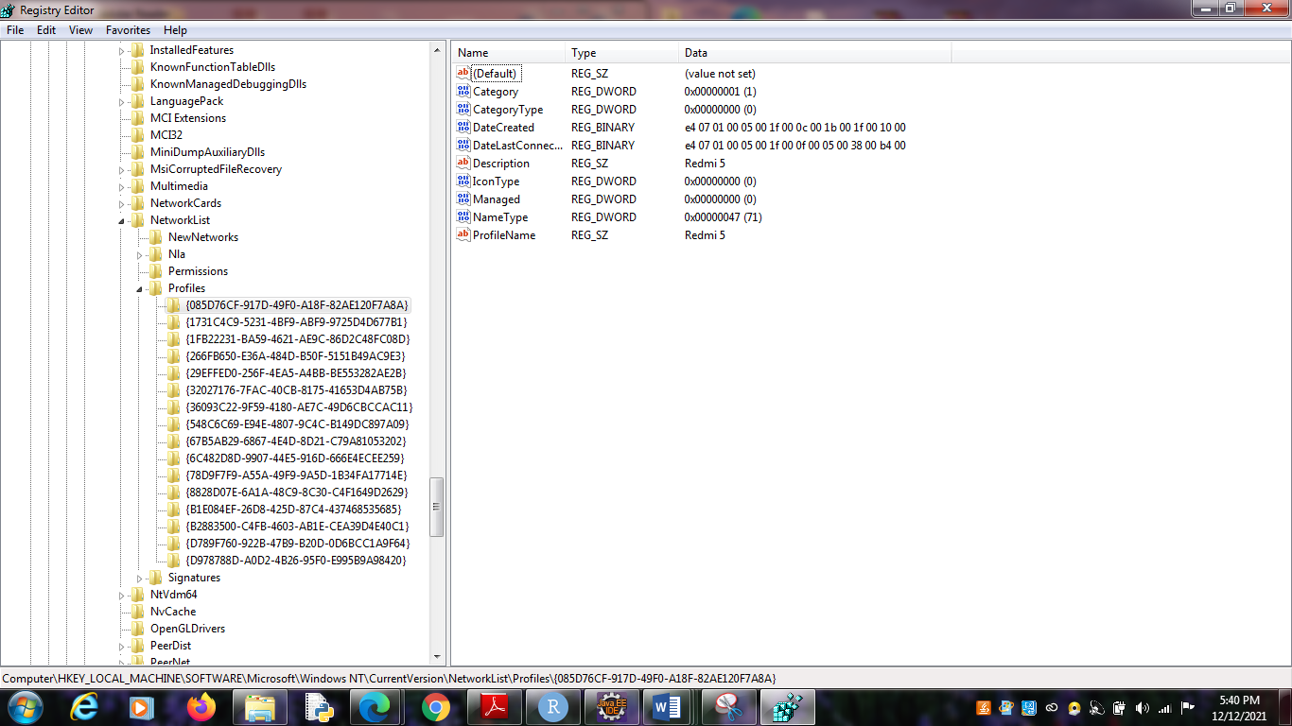

The RecentDocs Key

HKEY_LOCAL_MACHINE\SOFTWARE\Microsoft\Windows\CurrentVersion\Explorer\RecentDocs

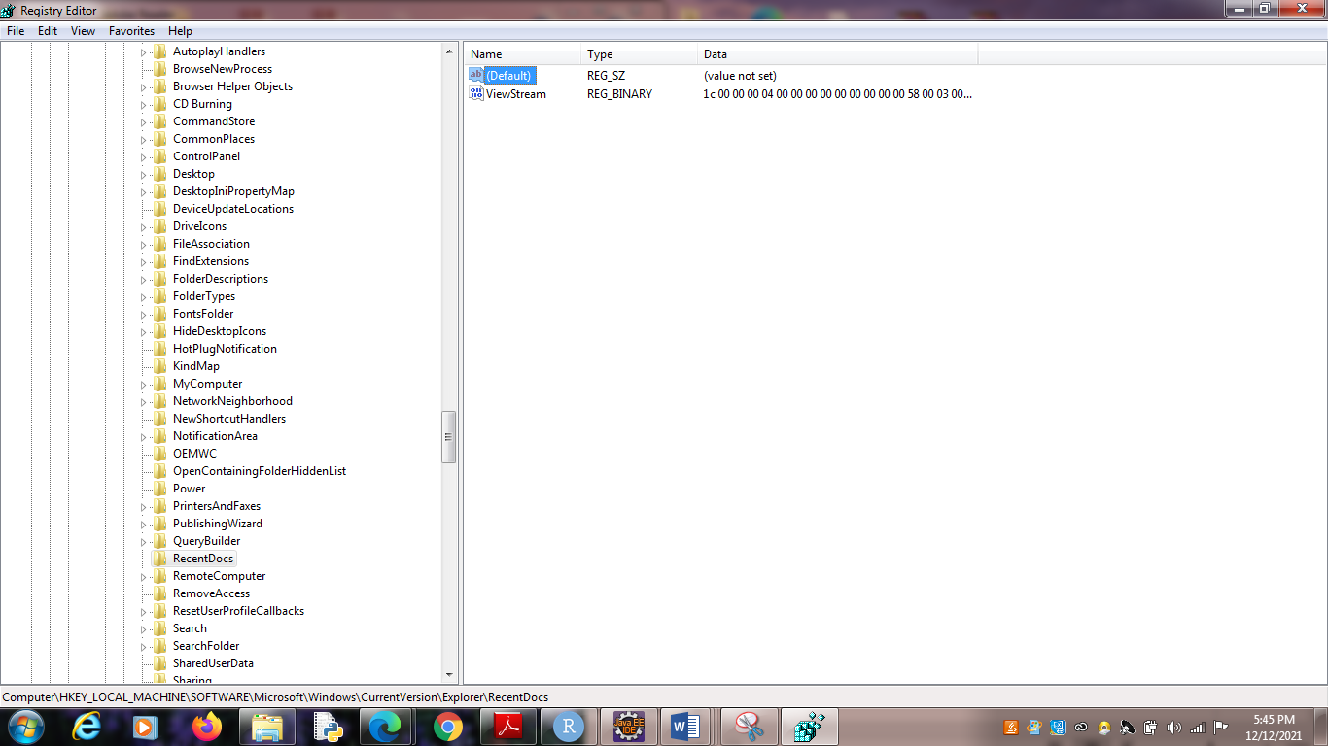

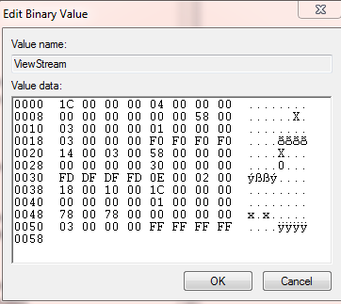

TypedURLs Key

HKEY CURRent USER\Software\Microsoft\Internet Explorer\TypedURLs

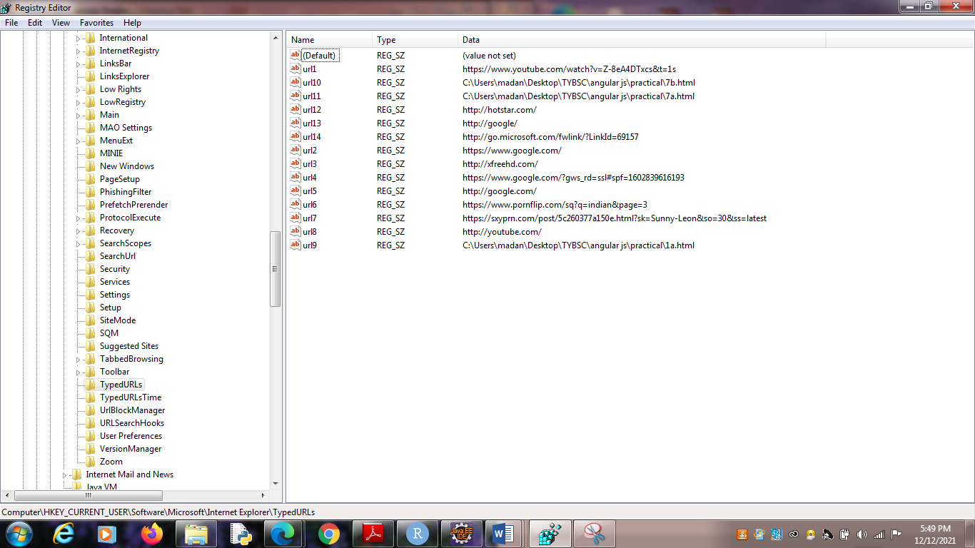

IP Addresses

HKEY_LOCAL_MACHINE\SYSTEM\CurrentControlSet\services\Tcpip\Parameters\Interface

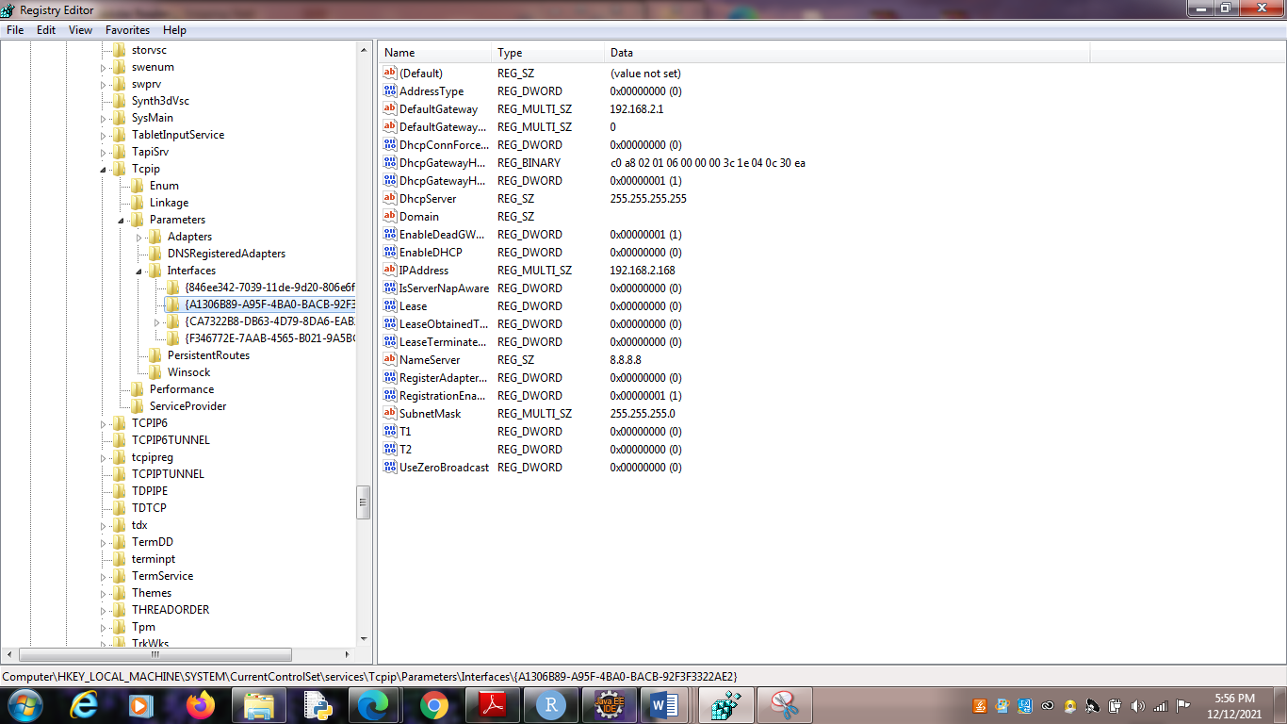

Start Up Locations in the Registry

HKEY_LOCAL_MACHINE\Software\Microsoft\Windows\CurrentVersion\Run

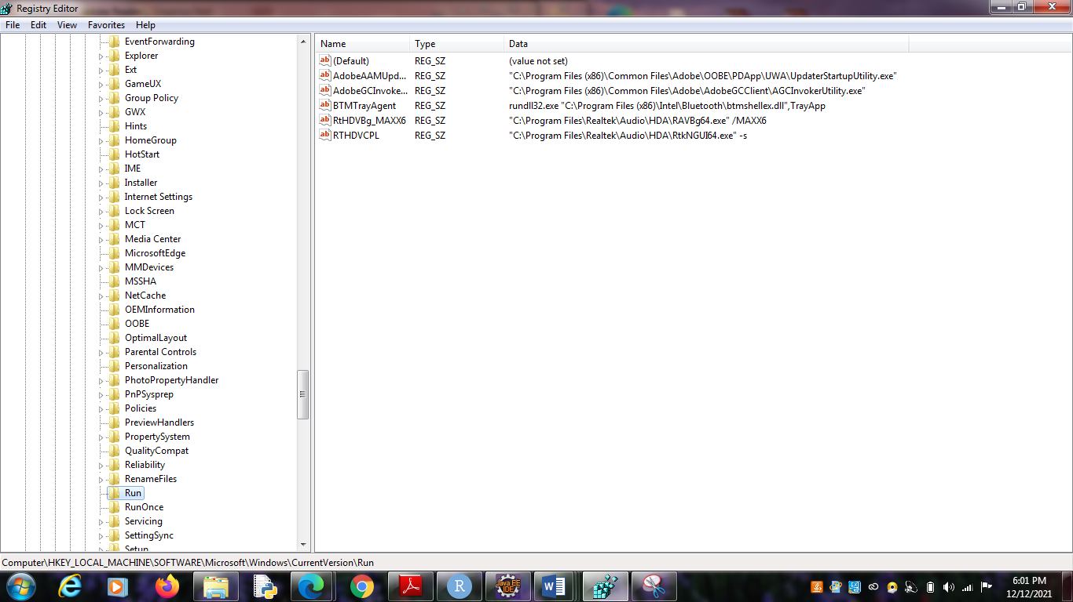

RunOnce Starup

HKEY_LOCAL_MACHINE\Software\Microsoft\Windows\CurrentVersion\RunOnce

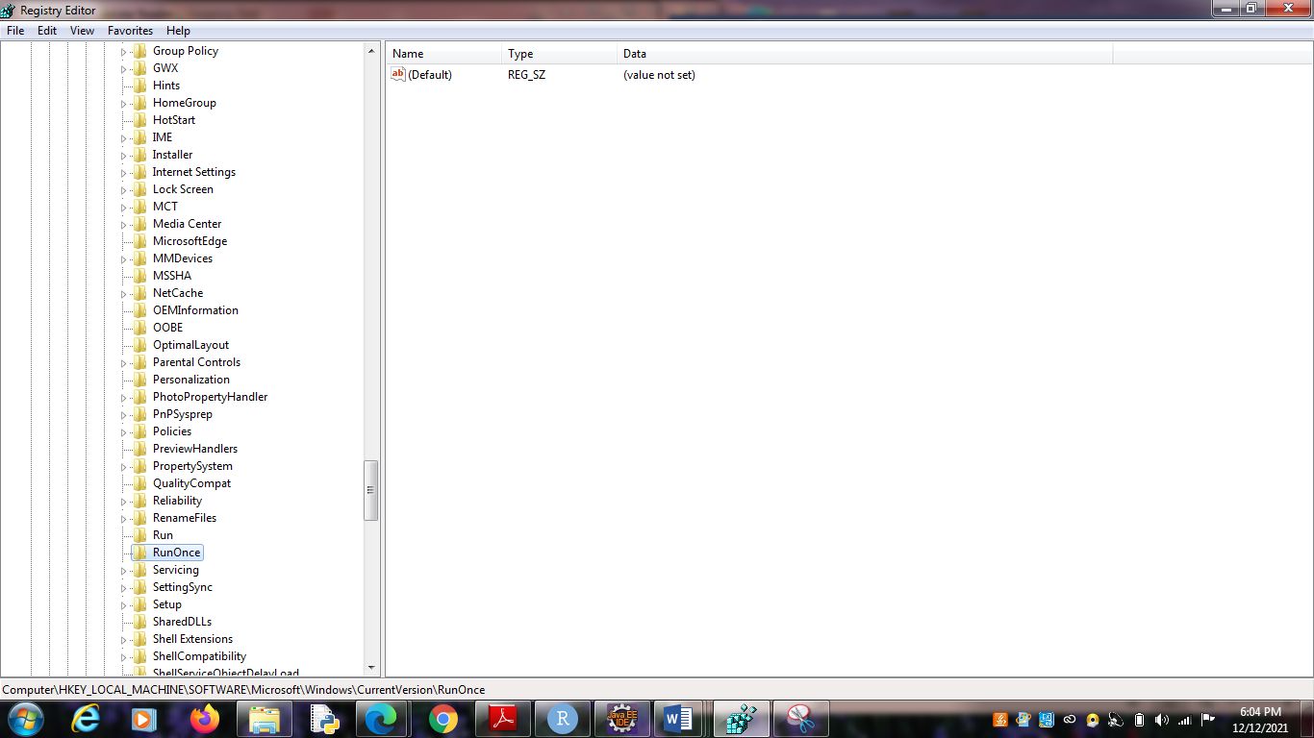

Start Up Services

HKEY_LOCAL_MACHINE\System\CurrentControlSet\Services

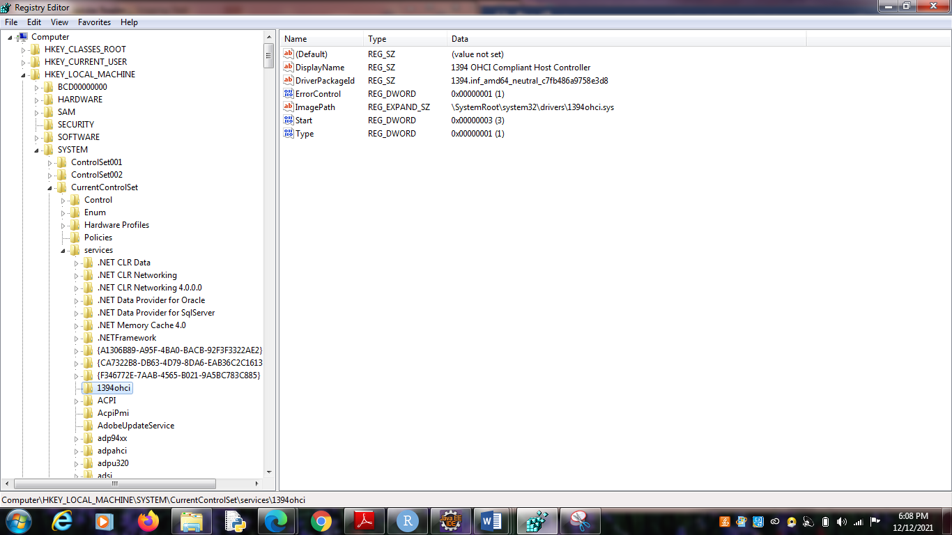

Start Legacy Applications

HKEY_LOCAL_MACHINE\System\CurrentControlSet\Control\WDI

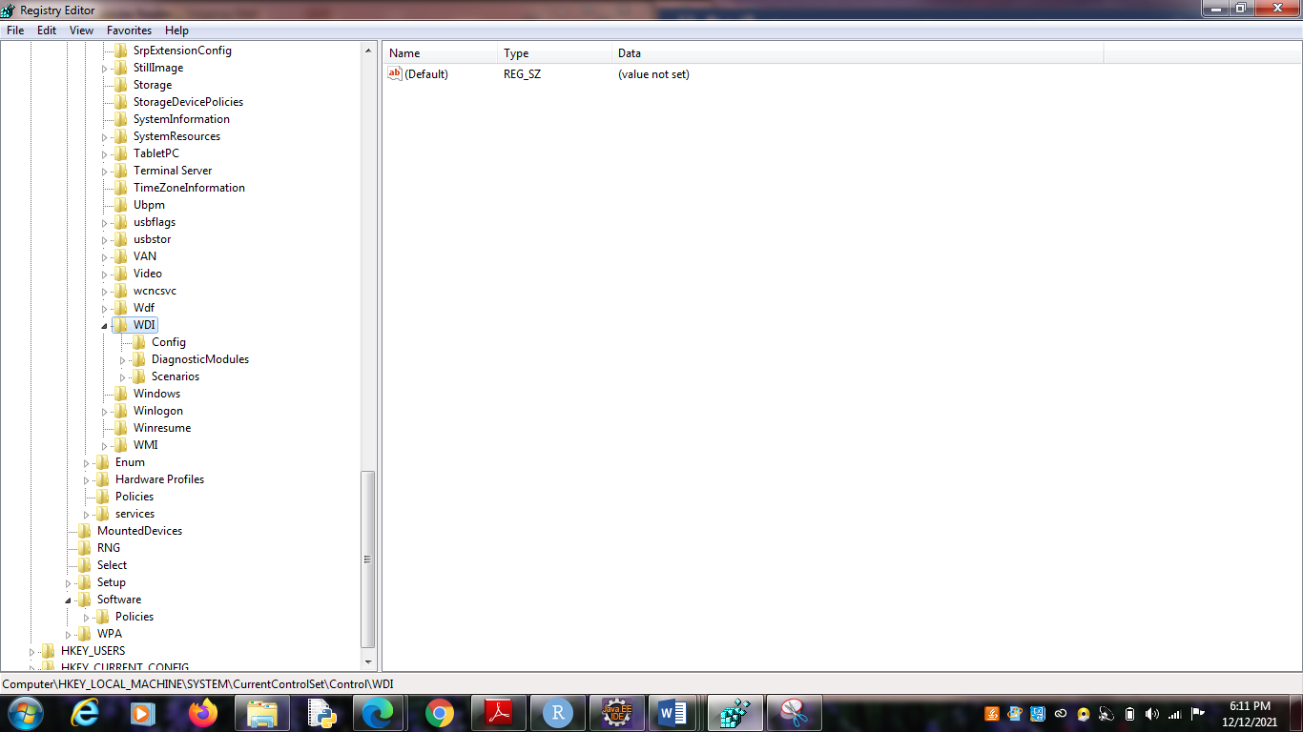

Start When a Particular User Logs On

HKEY_CURRENT_USER\Software\Microsoft\Windows\CurrentVersion\Run

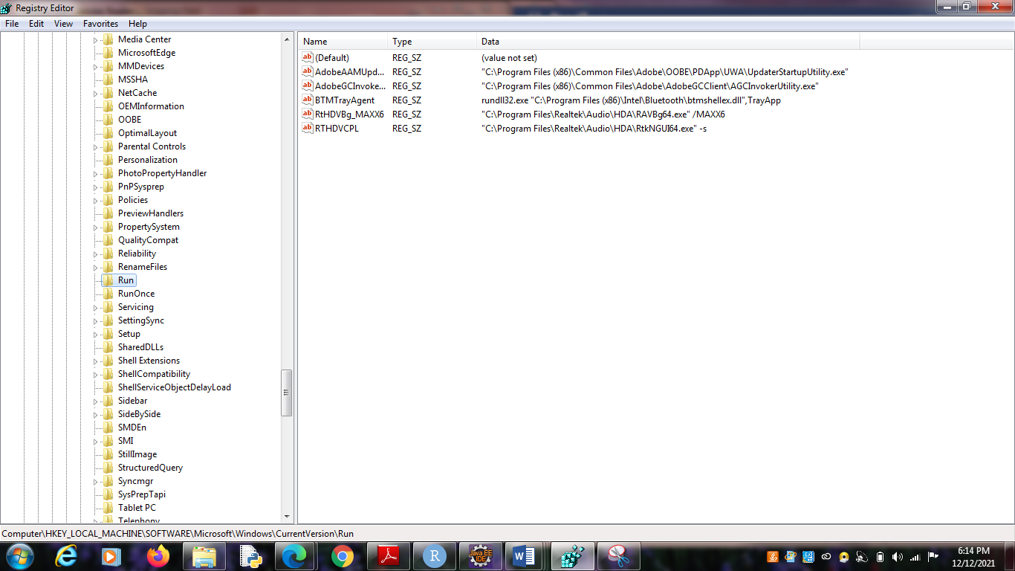

USB Storage Devices

HK_Local_Machine\System\ControlSet00x\Enum\USBSTOR

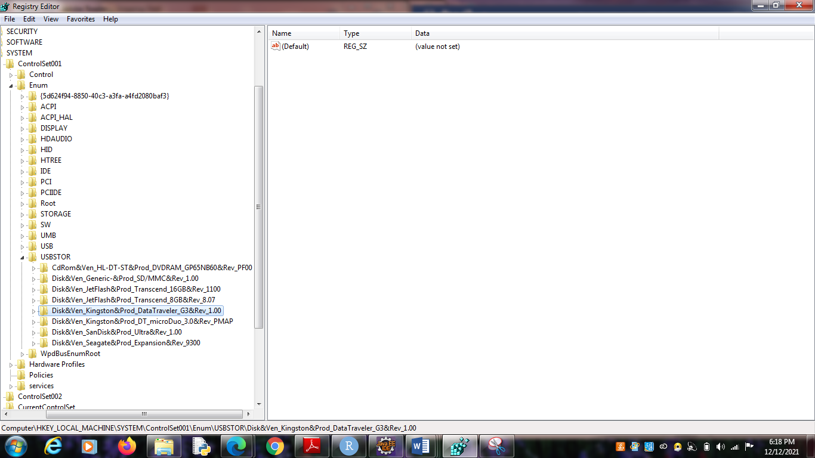

Mounted Devices

HKEY_LOCAL_MACHINE\System\MountedDevices

